**2.(f)**

The plot of the log-likelihood vs iteration is as follows:

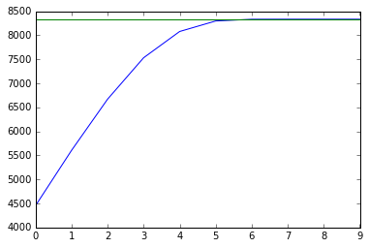

The estimated model parameters are:

9.96979256, 4.90985978, 14.86165346, 19.66495057, 48.97431779

**4.(a)**

The plot of objective function is   
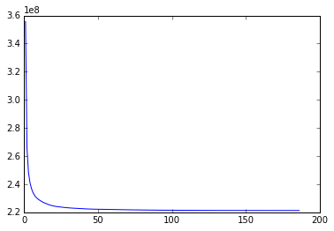

Put the two pictures together:

**Compressed Original**

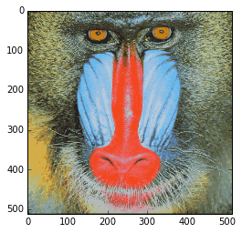 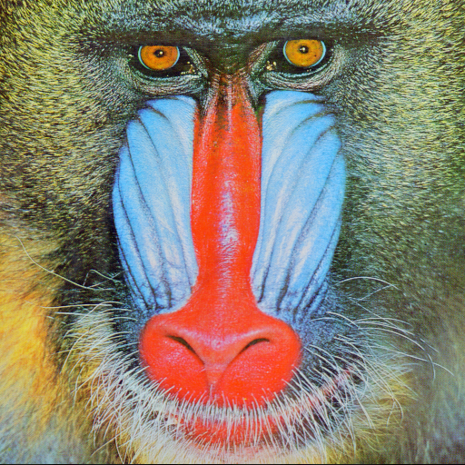

Comparing the compressed picture with the original one, we can find the large parts with single color are best preserved. For the border parts where the color changes from one to another, they are generally not preserved well.

The picture of the difference:

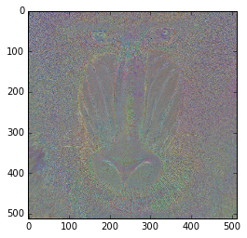

The compression ratio is :

The relative mean absolute error of the compresses image is: 0.05

**4.(b)**

The number of 24 bits per pixel needed:

the compress ratio is:

**5.(e)**

The plot of the log-likelihood is :

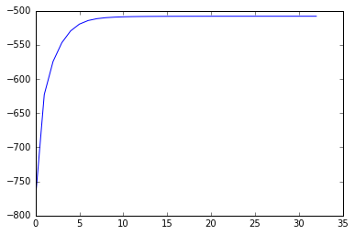

The estimated model parameters:

The plot showing the data and estimated lines is :

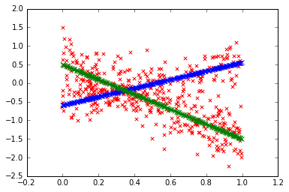

**Codes:**

#2.f

import numpy as np

from matplotlib import pyplot as plt

from scipy.special import gammaln, polygamma

from __future__ import division

N = 1000

m = 5

alpha = np.array([10, 5, 15, 20, 50])

P = np.random.dirichlet(alpha, N)

t=np.sum(np.log(P),axis=0)/N

t=t.reshape((5,1))

U=np.ones((5,1))

alpha0=np.ones((5,1))

loglihd=np.zeros((1000,1))

for i in range(1000):

dalpha1=N*(t+polygamma(0,np.sum(alpha0))*U-polygamma(0,alpha0));

g1=-N*polygamma(1,alpha0)

Q=np.diag(np.diag(np.ones((5,5))*g1))

C=N*polygamma(1,np.sum(alpha0))

Q1=np.linalg.inv(Q)

alphan=alpha0-(Q1-(Q1.dot(C*U.dot(U.T)).dot(Q1))/(1+C*U.T.dot(Q1).dot(U))).dot(dalpha1)

loglihd[i]=N*((alphan-1).T.dot(t)+gammaln(np.sum(alphan))-np.sum(gammaln(alphan)))

if i==0:

alpha0=alphan

elif i > 0 and np.abs(loglihd[i]-loglihd[i-1])>0.0001:

alpha0=alphan

else:

alphafnl=alphan

break

lstd=N*((alpha-1).T.dot(t)+gammaln(np.sum(alpha))-np.sum(gammaln(alpha)))

x=np.linspace(0,9,10);y=loglihd[0:10];stdl=lstd*np.ones((10,1))

plt.plot(x,y);plt.plot(x,stdl)

#4.a

import numpy as np

from matplotlib import pyplot as plt

from __future__ import division

from scipy.ndimage import imread

mandrill = imread('mandrill.png', mode='RGB').astype(float)

N = int(mandrill.shape[0])

M = 2;k = 64

X = np.zeros((N**2//M**2, 3*M**2))

for i in range(N//M):

for j in range(N//M):

X[i*N//M+j,:] = mandrill[i*M:(i+1)*M,j*M:(j+1)*M,:].reshape(3*M**2)

Jf=np.zeros((300,1))

#calculating tagfet value J

def calcJ(data,centers):

diffsq=(centers[:,np.newaxis,:]-data)**2

return np.sum(np.min(np.sum(diffsq,axis=2),axis=0))

#implement k means

def kmeans(data,k):

#initializing centers and list J

centers=data[np.random.choice(range(data.shape[0]),k,replace=False),:]

J=[];

#closest center for each sample

for itera in range(300):

sqdistances=np.sum((centers[:,np.newaxis,:]-data)**2,axis=2)

closest=np.argmin(sqdistances,axis=0)

#calculate J and append to list

J.append(calcJ(data,centers))

Jf[itera]=calcJ(data,centers)

#update clusters

for i in range(k):

centers[i,:]=data[closest==i,:].mean(axis=0)

#decide whether stopping

if itera>0 and np.abs(Jf[itera]-Jf[itera-1])==0:

X=centers[closest,:]

break

else:

continue

J.append(calcJ(data,centers))

return J,centers,closest

JF,centersf,closestf=kmeans(X,64)

Xnew=centersf[closestf,:]

mandrillnew=np.zeros(512*512*3)

mandrillnew=mandrillnew.reshape(512,512,3)

for i in range(256):

for j in range(256):

mandrillnew[i*2:(i+1)*2,j*2:(j+1)*2,:]=Xnew[i*256+j,:].reshape(2,2,3)

plt.imshow(mandrillnew/255)

plt.show()

mandrillgrey=mandrillnew-mandrill+128*np.ones(512*512*3).reshape(512,512,3)

plt.imshow(mandrillgrey/255)

plt.show()

Jf1=Jf[Jf>0]

x1=np.linspace(1,186,186)

plt.plot(x1,Jf1)

error=np.sum(np.abs(mandrillnew-mandrill))/(3*255*512**2)

#5.e

from __future__ import division

import numpy as np

from matplotlib import pyplot as plt

from scipy.stats import norm as norm

# Generate the data according to the specification in the homework description

N = 500

x = np.random.rand(N)

pi0 = np.array([0.7, 0.3])

w0 = np.array([-2, 1])

b0 = np.array([0.5, -0.5])

sigma0 = np.array([.4, .3])

y = np.zeros_like(x)

for i in range(N):

k = 0 if np.random.rand() < pi0[0] else 1

y[i] = w0[k]*x[i] + b0[k] + np.random.randn()*sigma0[k]

ccpiest = np.array([0.5, 0.5]);cwest = np.array([1, -1])

cbest = np.array([0, 0]);sigmaest = np.array([np.std(y), np.std(y)])

cwest2 = np.array([cwest,cbest]).T;x2 = np.array([x,np.ones(N)])

p1 = ccpiest[0]*norm(cwest2[0].dot(x2),sigmaest[0]).pdf(y)

p2 = ccpiest[1]*norm(cwest2[1].dot(x2),sigmaest[1]).pdf(y)

r1 = p1/(p1+p2);r2 = p2/(p1+p2);r = np.array([r1,r2])

Q1 = np.sum(r1*np.log(ccpiest[0]*norm(cwest2[0].dot(x2),sigmaest[0]).pdf(y)))

Q2 = np.sum(r2*np.log(ccpiest[1]*norm(cwest2[1].dot(x2),sigmaest[1]).pdf(y)))

Q = Q1+Q2;diff = 1;ll = [];ite = [];count = 0

for i in range(100):

ll.append(Q);ite.append(count);tmp = Q

ccpiest = np.array([np.mean(r1),np.mean(r2)])

w1 = np.linalg.inv(x2.dot(np.diag(r1)).dot(x2.T)).dot(x2).dot(np.diag(r1)).dot(y)

w2 = np.linalg.inv(x2.dot(np.diag(r2)).dot(x2.T)).dot(x2).dot(np.diag(r2)).dot(y)

cwest2 = np.array([w1,w2])

sigmaest1 = ((np.sum(r1*(y-cwest2[0].dot(x2))**2))/np.sum(r1))**0.5

sigmaest2 = ((np.sum(r2*(y-cwest2[1].dot(x2))**2))/np.sum(r2))**0.5

sigmaest = np.array([sigmaest1,sigmaest2])

p1 = ccpiest[0]*norm(cwest2[0].dot(x2),sigmaest[0]).pdf(y)

p2 = ccpiest[1]*norm(cwest2[1].dot(x2),sigmaest[1]).pdf(y)

r1 = p1/(p1+p2);r2 = p2/(p1+p2);r = np.array([r1,r2])

Q1 = np.sum(r1*np.log(ccpiest[0]*norm(cwest2[0].dot(x2),sigmaest[0]).pdf(y)))

Q2 = np.sum(r2*np.log(ccpiest[1]*norm(cwest2[1].dot(x2),sigmaest[1]).pdf(y)))

Q = Q1+Q2;diff = Q-tmp;count = count+1

if diff>=1e-4:

continue

else:

break

plt.plot(x, cwest2[0].dot(x2), c='b', marker='x')

plt.plot(x, cwest2[1].dot(x2), c='g', marker='x')

plt.scatter(x, y, c='r', marker='x')

plt.plot(ite,ll)